WREN NEWS
Newsletter of the Wadebridge Renewable Energy Network | DECEMBER 2012
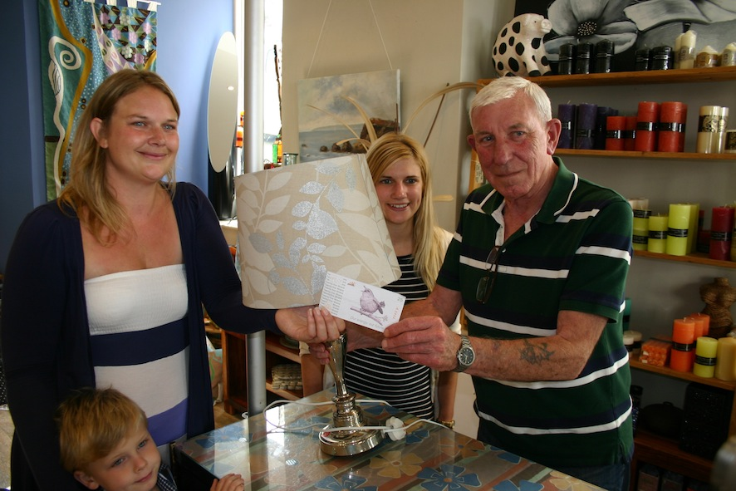  Artycrafts receive the very first Wr25.  From L-R: Laura Knightley, Katie Chowiencyzk and Fred Hardie from Artycrafts.  £7,845 a year saved on local energy bills and £1,975 spent in local businesses!  Our free cavity wall and loft insulation offer was a great success. Thanks to you, the people of Wadebridge and the surrounding areas, we have together insulated 79 homes with another 16 more to be done before Christmas. So far we have saved £7,845 a year on local energy bills, saved 33.5 tonnes of CO₂ and generated over £1,975 in the form of Wr25, for local businesses.  WrEN offers  ‘FREE’ PV and BIOMASS BOILERS  WREN is shortly to set up the WREN Energy Company, and we are looking for domestic and commercial roofs to host community owned PV and commercial buildings to host biomass heating systems. You get the free electricity or reduced cost heat, and any tariffs go to repay costs and towards the WREN Community Fund. If you are interested, or would like to know more, please email jerry.clark@wren.uk.com  At WREN we’ve been working hard over the last couple of months to evaluate the best local trusted installers and suppliers to offer some great renewable energy systems and low carbon technology. All WREN's recommended installers and suppliers are fully accredited, insured and vetted by WREN for their experience, value for money and use of quality products.  By choosing WREN Offers your local community benefits too. For every offer taken up, the supplier will pay a contribution to the WREN Community Fund.  WREN OFFERS FOR YOUR BUSINESS  Commercial Solar PV - Are you a business looking to save money and produce your own electricity? We can install all sizes of systems. For example, prices for 10kW of PV start from £12,950 plus you get Wr25 and a donation on your behalf to the Community Fund.  Commercial Biomass Heating – Are you a business looking to save money, make money and reduce your carbon footprint? By switching from a fossil fuel system you can benefit from the Renewable Heat Incentive and cheaper fuel costs. We can offer biomass heating systems tailored to suit your business with local and trusted installers.  WREN OFFERS FOR YOUR HOME  Domestic Solar PV – Guess what? The price of solar panels has more than halved in the last year and the Feed In Tariff (FIT) is at 15.44p per kWh. What does this mean? Solar panels payback in 6-8 years giving you at least 12 years of free electricity and an income stream! We offer all sizes of domestic PV – for example 4kW starts at £6,450 plus you get Wr25 and a donation on your behalf to the Community Fund.  100% renewable electricity tariff from Good Energy – Want to have an electricity tariff that’s inflation proof, is not generated from fossil fuels and will reduce your carbon footprint? WREN has negotiated with Good Energy to give you Wr25 and a donation on your behalf to the Community Fund if you switch to their 100% renewable electricity tariff. To find more go to www.wren.uk.com/good-energy.html .  Range Cooker Conversion - Run your Range for as little as £300 per year by converting it from oil to electricity. Paybacks in as little as 2 years based on saving on oil costs – more news soon!  If you are interested in finding out more ….  Read more about WREN Offers at www.wren.uk.com/energy-shop/wren-offers.html , or come into the Energy Shop.  There is also further general information about the technologies on the website at www.wren.uk.com/generate-energy.html  Published by: Wadebridge Renewable Energy Network (WREN) Limited Registered in England, registration number 31236R. Registered address : 10 Meadow Head, Wadebridge, Cornwall, PL27 7PW. www.wren.uk.com.  You are receiving this newsletter as a member of WREN. If you wish to be removed from our mailing list, please write to membership@wren.uk.com | Stuck for a gift idea? Then Forget Robins, it’s Wrens this Christmas!  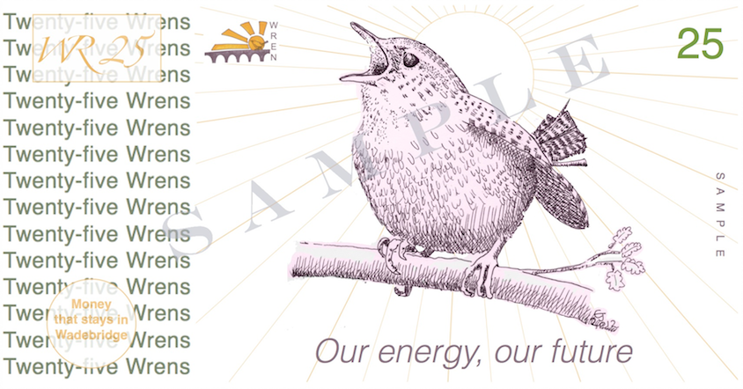  Above: the 25 Wren note  Don’t know what to get family and friends this Christmas? If you want to support local shops, keep money spent at Christmas in Wadebridge and contribute to the WREN Community Fund, then why not give a Wren note?  Our Wr25 notes are available from The Energy Shop with a locally designed card to make the perfect local gift. There are over 50 businesses in Wadebridge that accept Wrens (see overleaf for details) and for each WR25 note redeemed the business will donate £2.50 to The Community Fund.  CHRISTMAS FAMILY FUN  We are running a FREE Christmas Family Drop in Day on Saturday the 15th of December between  11-am – 3pm.  Come and make your own Christmas decorations out of recycled materials. We even have a green Santa and low carbon Christmas display! You can find out more about how to have a greener Christmas at www.wren.uk.com/greenchristmas  Over 50 local businesses that have agreed to take the Wren currency:  - Alexander & Co  - Artycrafts (all three shops)  - Astons Carpets  - Babes ‘n’ Bikes  - Bloom Room Flowers  - Bricknells  - Bridge Bistro  - Brooks & Jeal  - Carraways Cafe  - Choc A Bloc  - Cleanearth  - David Wood EPC Assessor  - Depicture Photoshop  - Elixir Health  - Fusion  - Glanvilles  - Helen Sanderson Dressmaker  - Hobgoblin  - Impress51  - Indigo Clothing  - Little Living  - Local Eyes  - Lola Smith Clothing  - Manna Tea Room  - Matchbox  - Michael Scott Photography  - Natural Radiance Reflexology  - One Step Ahead  - Relish  - Rural Urban  - Senta  - Shooting Star  - Sticky Fingers Nursery  - The Barber Shop  - The Bridge On Wool  - The Carpet Trader  - The Glasshouse  - The Heat Store  - The North Cornwall Advertiser (payment against advertising)  - The Shoe Boy  - The Vine  - Tile Italia  - Trelawney Garden Centre  - Vivienne’s Fashion Fabrics  - Wadebridge Bookshop  - Wadebridge Wines  - Warnes Restaurant & Bar (Former TC's)  - Williams & Sons Butchers  - Woolacotts

